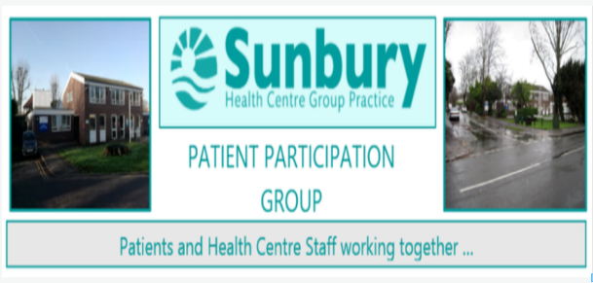

PATIENT SURVEY RESULTS
OBSERVATIONS AND RECOMMENDATIONS PUBLISHED

The Patient Survey, conducted by the Patient Participation Group (PPG) last year, has now been published on the PPG and Sunbury Health Centre websites.
The Survey report, PPG analysis, observations and recommendations have been reviewed by the Partners and Practice Management Team and discused with the PPG Core Group. These discussions will determine priorities that the Practice and PPG Core Group will seek to address moving forward.
One of the main concerns raised by patients was regarding the limited time slot available each day when requesting an appointment using the on-line system. The reasons that the time slow was set at 8.00am – 11.00am ws to ensure patient safety by allowing all requests coming in to be triaged efficiently.
The Practice has installed a new on-line system since the Survey took place, and now that the newsystem is bedded in, the on-line booking slot has been extended to run from 8.00am – 1.00pm. This will be a welcome development for many patients.
With over 6,000 appoint requests coming into the Practice each month, the triage system is essential inensuring that patients see the appropriate Practitioner for their needs. The Survey shows that 80% of patients felt they had been directed to the right person.
The role of a ‘Receptionist’ is long gone, and the modern triage team undergo significant and complex training to support them in allocating patients approriately and a GP is always on hand to provide guidance when required.
Please take the opportunity to look at the PPG Survey Report which, although very detailed, does have an overview of strengths and recommendations near the beginning. We shall be exploring more of the recommendations in our article over the coming months.

www.sunburyhealthcentre-ppg.com www.sunburyhealthcentre.nhs.uk

