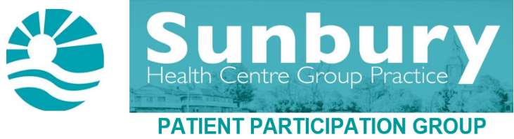

SUNBURY HEALTH CENTRE AND THE HOME VISIT PARAMEDIC
An interview with Sophie

Name: Sophie
Job Role: Community Paramedic

How long have you been with the Sunbury Health Centre?
Since December 2021.

What was your job before Sunbury Health Centre / previous experience?
London Ambulance Service.

What training is necessary to become a Paramedic?
Three-year University Degree BSc (Hons) Paramedic Science.

Do Paramedics specialise in certain types of treatment conditions? Or are they similar to GPs, having knowledge about lots of different conditions?
Paramedics specialise in a range of emergency and non-emergency situations, using judgement and skills to quickly assess a patient’s condition and provide ongoing care or referrals.
The role of the Paramedic has developed over recent years to meet the shifting needs of healthcare towards community provision, aimed at supporting patients to be treated and managed within their own home.
Similar to GPs, Paramedics have knowledge about lots of different conditions.
What makes a Paramedic specialise in Home visits?
Paramedics possess the knowledge, leadership and complex skills needed for home visiting, as they are experienced practitioners able to assess and manage health conditions with the support of the GPs.
Paramedics also work closely with other health and social care teams in the community, such as social services, to avoid unnecessary hospital admissions.
As well as responding to urgent home visit requests, Paramedics will visit for routine assessments, such as COPD, Asthma, Dementia and Diabetic reviews.

When would a home visit from a Paramedic be more appropriate than a GP?
Housebound patients are generally more vulnerable and/or frail than those patients who can attend the Health Centre.
Paramedics have the capacity to spend time getting to know the patients and are, therefore, able to assist with multiple health and social care needs during the visit.
This also means that Paramedics act as a ‘health advocate’ for the patient, helping patients communicate with the healthcare providers, so that they get the information they need to make an informed decision about their health care.

Can Paramedics prescribe/modify medication?
Certain Paramedics can prescribe if they have completed an accredited independent prescribing course.
Paramedics who do not prescribe, work very closely with the duty GP, so that if a prescription is required, this can still be done urgently.

Can Paramedics refer a patient to hospital/A&E?
Yes. However, this does not necessarily mean patients will be seen any quicker at the hospital/A&E.
Patients will be triaged by hospital staff when they arrive, no matter their method of arrival, or if they have been referred or not.

Can you tell us anything interesting about your role, that we might not know?
The word Paramedic is a combination of two terms – ‘Para’ means next to, and ‘medic’ means Doctor.
This means that Paramedics are much more than ‘Ambulance Drivers’, they are highly trained and have a broad scope of practice, working within the multi-disciplinary team.

Sunbury Matters – April 2023 – Issue 142
www.sunburyhealthcentre-ppg.com

