Sunbury Health Centre Group Practice
Newsletter - Autumn 2014
www.sunburyhealthcentre.co.uk
Tel 01932 713399
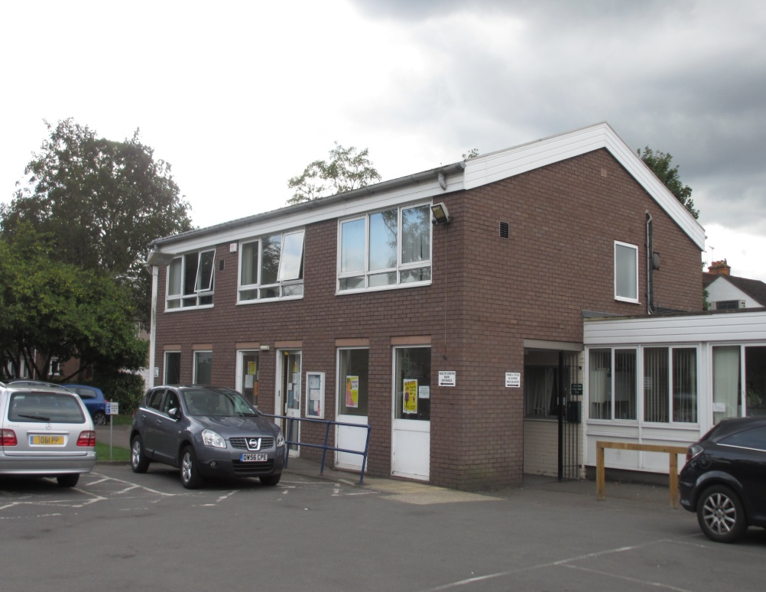
Welcome to the Autumn edition of Sunbury Health Centre Group Practice quarterly newsletter, informing our patients of the latest news from the Practice.
It has been a challenging year with many recent NHS changes from April 2013, culminating in funding cuts to our service. Clinical Commissioning Groups (CCGs) have been formed nationally replacing the old Primary Care Trusts (PCTs).
We continue to work from a very old and tired NHS property building. Our infra-structure is designed for 6,000 patients, but due to increasing numbers of people moving into the Sunbury area - and the closure of a local small GP Practice some years ago, we now have a list of near 19,000 patients, making us one of the biggest Practices in the country. We are currently 84% undersized.
We should like to remind all our patients that we do not own the premises, but rent 45% of the space in this old Health Centre owned by NHS Properties. Virgin Health, a provider of community services like the district nursing team, rent the remaining 55%.

Appointments/Access
A few months ago we altered our appointment system at the surgery. We now offer half the appointments to be booked on the day, and half to be booked in advance. We encourage you to book in advance if it is a routine problem, as the surgery can get very busy in the mornings. The allocation of on-the-day appointments is released at 7:00am and 8:30am. These can be booked in person or on the phone.

Booking in advance eases the pressures on the morning queue.
The surgery has recently purchased four more telephone lines to try to improve access by phone. As a result of patient feedback, we spoke to our telecommunications provider and we now have a telephone queuing system in place.
The surgery now offers on-line booking for appointments. In order to take advantage of this, you will require a code from our Reception. This can be issued on receipt of some photo ID.
We like to remind patients we have an emergency Doctor on-call everyday to deals with emergencies outside the routine work. This service should be used for those who are acutely unwell and emergencies needing to see or speak to a Doctor on the same day.
Sunbury Health Centre Group Practice is one of the very few remaining Practices in the country to provide ‘named Doctors’ for all patients as we strive for continuity. A patient may not always be able to see their own Doctor, but we work as a team and all Doctors have access to the same records. For your own benefit, please try to see the same Doctor who ordered any tests for the results of those tests.
All Doctors have ten minute appointments. The Doctors try their very best to deal with the problems in this time. Sometimes your Doctor may ask you to book another appointment to address further problems. This is only fair on other patients waiting - but also, more importantly, to give the patient more time so no diagnosis is missed.

Staff
Dr Dave Gill joined as a Partner in April 2013, replacing Dr. Richard Barnett. Dr. Mark Jopling joined as a new Partner in January 2014, replacing Dr. Simon Holmes. Both come to the Practice with new ideas and lots of experience, and both also offer ‘joint injections’.
We are pleased to welcome Dr. Caroline Guppy, who replaces Dr. Lisa Linsky, and Dr. Beatrice Smith who replaces Dr. Alice Danczak. We wish both Dr. Lisa Linsky and Dr. Alice Danczak well and every success in their future careers.
We are very excited to welcome our new Nurse, Sister Lisa Cook. She is a very senior and experienced Nurse. We have now expanded our Nursing Team to four Nurses who now look after many of the chronic diseases.
Jackie Sheehan, our new Office Manager, has been in post for one year. She has been working very hard with all her Reception Team to improve internal systems.
The Reception staff work very hard and endeavour to answer all enquiries. They perform many vital roles in running of the surgery. Unfortunately, due to increasing demand with a big shift in work coming from hospitals and our limited space, their jobs are getting increasingly difficult. This is compounded by the fact our very small surgery can reach capacity very quickly.
We continue to look to recruit more staff and appeal to our patients to bear this in mind.
Without our excellent and very loyal non-clinical members of staff, our Health Centre would not be able to function.

New Developments
Dr. Gill is embarking on a three-year Post Graduate Medical Education Certificate, with the aim to make Sunbury Health Centre Group Practice a training Practice. Hopefully, in the not too distant future, we will have one or two fully qualified Doctors - who are training to become General Practitioners - working under supervision in the Practice. We are excited at the prospect of educating the GPs of the future. Dr. Mark Jopling will also be starting his three-year course in September 2015.
Dr. Rogers, Dr. Perinparajah, and Sister Charlotte Budkiewicz have been working very hard in their spare time - and on weekends - completing Ddiplomas in Diabetes, based at Warwick University. We now boast a very strong Diabetes Team, in addition to Sister Maura Hood who has led the service so well for many years.

Patient Participation Group (PPG)
Our Patient Participation Group is expanding and flourishing - thanks to the dedication and hard work of Helen O’Shea, Paul Thompson, Brian Catt, Neil Huntingford, Polly Healy and many others. Helen O’Shea has now left the PPG and we thank her for setting this group up over the years.
We meet on a regular basis and enjoy working together to improve the Health Centre. Everyone is welcome to attend the ‘open evenings’ or voice any questions.
We recently agreed to fund the PPG website - contact details are www.sunburyhealthcentre-ppg.com and encourage our patients to get involved in the evening meetings. The next open meeting is Monday 27th October at 6:30pm at Sunbury Health Centre, all are welcome.
We have worked together on projects such as tidying the waiting room, looking at ways to improve access to appointments, designing patient surveys as well as working together on our NHS England applications. We hope to continue to build on this strong relationship. The PPG has supported us by putting pressure on the appropriate bodies to try to improve or acquire new premises.

New Medical Services
Sunbury Health Centre has agreed to undertake the government-backed Care Plans for our patients. We are making Care Plans for the frailest 2% of the adult patient population. Like all patients, they have a ‘named Doctor’ and we shall be documenting frailty scores for them. We have written to these patients. Any questions about this, please ask your Doctor or Nurse at your next review.
We are striving to improve our patients’ chronic disease management by encouraging them to have annual Blood Pressure, Diabetes, Asthma, COPD, and Dementia reviews. We stress that it is important for patients to continue to have their annual reviews and medication reviews.
We encourage all the patients eligible for the flu jab, to book an appointment at our Saturday October Clinics. It is important that you get vaccinated for the winter season. All patient over 65 years - and patients with chronic medical problems - should attend. Please ask the surgery if you are unsure.
Our patients aged 70, 78, and 79 years on the 1st September 2014, are eligible for the Shingles vaccine and we encourage patients to book in for this.
We are also performing specific health checks for our patients with learning disabilities. We should like to encourage all patients, and their carers, to attend a review appointment. Dr. Canniff is our GP leading on this.
The Practice is also considering introducing a ‘texting system’ for the future and possible electronic prescribing. So obtaining patients’ mobile phone numbers and email addresses is vital. If we have alternative ways to contact patients, we can provide a better, more responsive service. Even if you don’t have an ongoing medical problem, it will be helpful if we know that we can contact you in different ways

Expanding Population
Our patient population is increasing with a great deal of new housing in the area. In the next three years, we anticipate a Practice population of 23,000 patients. Despite our concerns, Spelthorne Council continues to grant Planning Permission and allow ‘new builds’ in the area, with no consultation with the Practice.
We have expressed concerns - as has our PPG = but these amount to little change in local council housing policy.

Premises
We continue to fight and lobby for new premises. The Practice applied to NHS England in January 2014 for Practice Redevelopment, but we still have no news despite several meetings. We also applied to NHS England and NHS Properties in July 2014 for a Capital Grant to improve this very old building, but again have not heard anything more! We continue to have regular meetings with Spelthorne Council and have involved our local MP.
The Practice is speaking to Virgin Health Care with the aim of acquiring some underused space within this building. The patients of Sunbury Health Centre deserve better a primary healthcare infrastructure and we shall carry on this fight.

The Future
As we move forward, we continue to put pressure on the appropriate bodies to try to get new premises.
We continue to recruit more staff and expand our services. We look forward to becoming a ‘teaching Practice’ in the future.
Despite all the pressures from NHS England and Spelthorne Council we, at the Sunbury Health Centre Group Practice, endeavour to continue to deliver excellent primary care to our patient population.
Please feel free to give Sunbury Health Centre Group Practice feedback on www.nhs.uk … and if you have had a positive experience we would welcome knowing that too!

